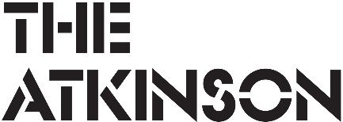 | theatkinson.co.uk  01704 533 333   | The Atkinson  Lord Street  Southport  PR8 1DB
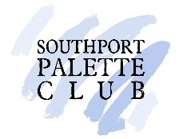
The Sefton Open 2026
In collaboration with Southport Palette Club

Artwork hand in day: Monday 16 March 2026, 11am - 7pm
Exhibition: 28 March - 30 May 2026

The Sefton Open is an annual exhibition celebrating the creativity and artistic talent across the borough. The exhibition takes over The Atkinson’s art gallery in an eclectic salon-style hang and features a wide variety of works. Each year the exhibition attracts thousands of visitors to The Atkinson.

The exhibition is formed of two halves; an open exhibition with artwork selected by Southport Palette Club, and a showcase of local art groups. To submit artwork, you must be aged 18+ with a connection to Sefton, e.g. live, work or have been educated in Sefton or the Liverpool City Region.

Individual artists may submit up to 3 original artworks to the open exhibition for consideration by Southport Palette Club. Submissions must have not previously been exhibited at The Atkinson or featured in the shop and all artwork must be for sale. A wide variety of media is welcomed, including film, sculpture, craft, paintings, prints and textiles.

There is a non-refundable £8 handling fee for each work submitted. No more than 4 works can be displayed by any individual artist in the Sefton Open, this includes works displayed in the open exhibition and works displayed with local art groups.

Local art groups can register for entry by contacting jemma.tynan@sefton.gov.uk to receive the groups and societies entry form.

The Atkinson’s longstanding partner, Southport Palette Club, was formed in 1921 to champion the work of local artists and this will be their 100th annual exhibition. In celebration of their centenary year Southport Palette Club are awarding prizes for ‘Best 2D’, ‘Best 3D’ and ‘Best Overall’ artwork from the artworks they select.

Visitors to the Sefton Open can purchase catalogues and are encouraged to vote for their favourite artwork on display. The artwork with the most votes will be awarded The People’s Prize. Visitors can also support local artists by investing in their work, artworks are available to purchase through The Atkinson, who is a member of the Own Art Scheme.
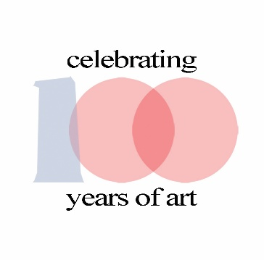
In the documents below you will find:
- Entry guidelines.
- Copyright guidelines.
- Information on how to prepare your artwork for submission.
- Entry form.

Entry Guidelines

- Artists may submit up to 3 original artworks for consideration by Southport Palette Club. No more than 4 works can be displayed by any individual artist in the Sefton Open: this includes works displayed through Southport Palette Club and works displayed through local groups.

- If you would like to submit a large sculpture/artwork, especially if it is larger than a person, this should be checked with jemma.tynan@sefton.gov.uk / 0151 934 2033 before the hand in day.

- Only new artwork will be accepted. The use of other people’s work, that is copyright free, that has been used as inspiration must reference the original image and/or artist through the title. No ‘like-for-like’ copies of other works will be accepted.

- The artist retains copyright of their artwork, but by submitting their work they agree that The Atkinson can take and publish images of the work to promote the exhibition and/or The Atkinson in the future at no cost.

- Reproduction photographic prints of original artwork will not be accepted.

- Physically drawn digital artwork will be accepted if the artist can state the drawing app used. AI generated artwork will not be accepted.

- Artworks must be presented in a suitable quality frame; e.g. clip frames will not be accepted. Canvases do not require an additional frame if the mirror plates can be securely fixed to the back.

- The Atkinson will subtract a commission of 25% from the sale price you provide. Southport Palette Club will subtract a commission of 5%. The total amount deducted from the artist will therefore be 30%. All items must be for sale so please consider this when deciding your sale price. All sales must be made through The Atkinson.

- The artist is responsible for packing their own works. No packing materials can be stored at The Atkinson. If using bubble wrap remember to place the bubbles on the outside to avoid damaging your work.

- It is the artist’s sole responsibility to insure their work against any loss or damage.

- For fairness, the hang is numerical and all artists have the same information provided in the exhibition catalogue for each artwork. We are unable to make any exceptions. Artworks labelled in any way to try to get around this rule will not be accepted, e.g. label placed within mount.

- There is a non-refundable £8 handling fee for each work submitted, payable in cash only on submission with your completed entry form.

All artworks must be submitted ready for hanging with the required labels and mirror plates. Please refer to the diagram sheet included below and the ‘how to’ film for full instructions: https://youtu.be/waDz32z19z8

Copyright Guidelines for artists

- It is OK to be inspired by other artists to help develop thoughts and ideas for your work, but artists should always make their own reference photographs and sketches.
- Theft of copyright occurs when you copy any work by another artist outside of personal study. This includes all artwork that is online and all photographs, even if several aspects of the work have been changed.
- Without proper permissions it is illegal to show, exhibit or publish any copy of another’s work you might have made, this includes posting on social media.
- If you find your work copied by another, you contact them and assert your copyright.

How copyright works
- Any artwork created is automatically protected by copyright law. There is no need to register copyright ownership, but it is always advisable to sign or mark all work of your own.
- The artist owns the copyright to their work and it lasts for 70 years after their death. Copyright ownership could be passed down to several descendants or beneficiaries before it expires.
- An artist keeps ownership of copyright even if their work is sold. The buyer could destroy the work if they wish as they own the physical object, but they cannot copy it and publish that copy or profit from it in any way without permission.
- Copyright of a work can be passed on or sold to someone else, once this has been done all rights then belong to the new copyright holder.
- Changes within copyright law over the years may mean that a work is within copyright still, even if the date makes you think it is not. It is always best to check.

If we are in doubt of any of the above for your artwork, it will not be included in the exhibition.

Important Dates
Artwork hand in day:
Monday 16 March 2026, 11am – 7pm
Artworks can be submitted on this day only. Posted forms will not be accepted.

Collection of unselected work before exhibition:
Friday 20 March 2026, 10am – 4pm
You will be contacted to collect your unselected artwork.
Southport Palette Club will not provide any explanation for unselected work.

Collection of unsold work at end of exhibition:
Tuesday 2 June 2026, 10am – 4.30pm
If you have not been contacted to say your artwork has been sold, please collect on this day.

Please note:
Unless The Atkinson is advised of problems collecting works on the dates stated any work not collected will incur a storage fee of £5 per day. If the artist does not contact The Atkinson to arrange a new collection date any uncollected artwork will be disposed of after seven days.

How to prepare your artwork for submission

1 & 2. Position mirror plates halfway down either side of back of frame pointing outwards.
3. Attach with small screws shorter than depth of frame.
4. Attach sticky label at bottom of back of frame.
5. Thread string through hanging label.
6. Attach (sticky tape is fine) hanging label in position on back of frame. Make sure hanging label can flop over front of frame but does not hang below frame at back.

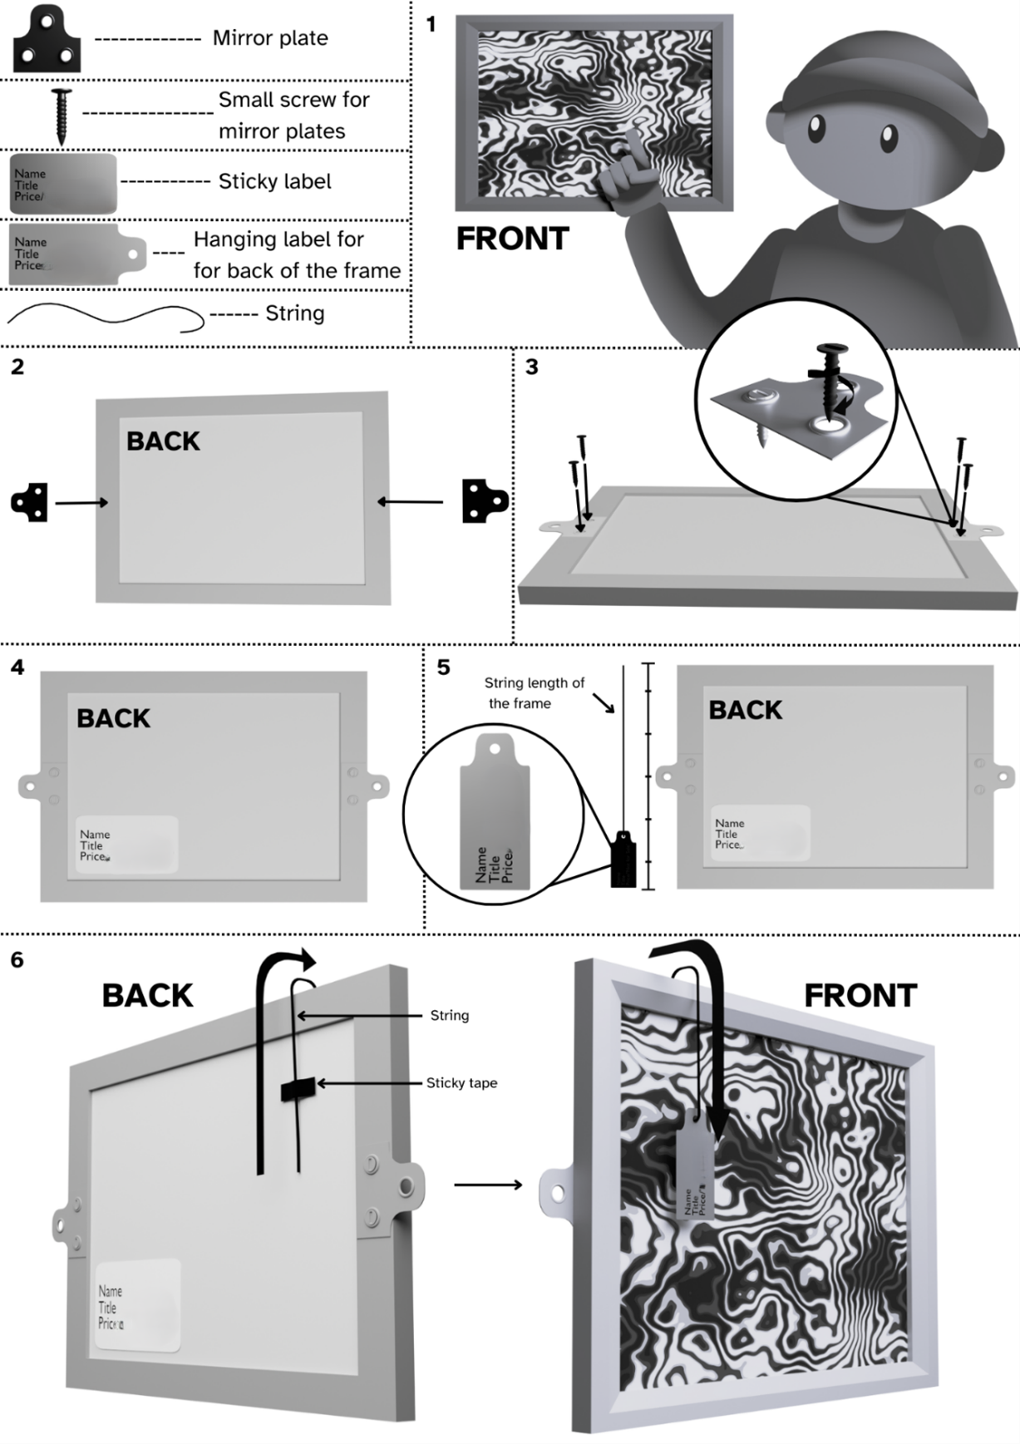
- Please label 3D works with a sticker on the base or attach a label by string to part of the work, somewhere that it can easily be removed for display.

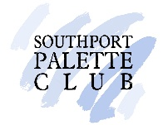 | theatkinson.co.uk  01704 533 333 | The Atkinson  Lord Street  Southport  PR8 1DB

Individual Artist Entry Form

The Sefton Open 2026
In collaboration with Southport Palette Club

Artwork hand in day: Monday 16 March 2026, 11am - 7pm
Exhibition: 28 March – 30 May 2026

Please complete the information below in block capitals. The completed form and £8 per artwork handling fee (cash) should be submitted to The Atkinson alongside your work on the hand in day.

Artist’s name |  | For catalogue inclusion: |  | Legal name to write on cheque if work sells if different to previous:
Address
Telephone number
Email address
 | Artwork Title |  |  |  | Medium | Price £
1.
2.
3.
Terms & Conditions:
- I agree to pay the £8 per artwork entry fee and a commission charge of 30% of the selling price of each piece sold.

- I accept that all submissions will be included for the full duration of the exhibition, however, The Atkinson retains the right to remove any artwork from display without explanation.

- I confirm that no copies of my artwork will be on sale elsewhere within The Atkinson during the time it is displayed in this exhibition and it has not been displayed with The Atkinson before The Sefton Open 2026.

- Insurance is a matter for individual exhibitors. Southport Palette Club or The Atkinson will not accept responsibility for loss or damage to exhibits or entries, however it may be incurred.

- I accept that as an exhibitor, by agreeing to take part in the event, I accept liability.

- I confirm that all submissions are original artworks or clearly refer to any works or artists that have been legitimately used for inspiration and I understand that any works found to be in breach of copyright law will be removed immediately.

- I agree that The Atkinson can freely take images of my artwork and use these as required for business needs.

- I understand that I can exhibit no more than 4 works across the whole of the Sefton Open, inclusive of the 3 original artworks for consideration by Southport Palette Club and that they all must be for sale.

Please sign to show your acceptance of
the terms & conditions:

