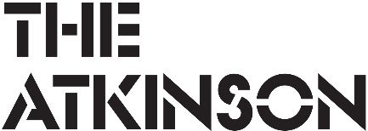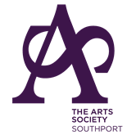 | theatkinson.co.uk  01704 533 333   | The Atkinson  Lord Street  Southport  PR8 1DB

Inspirations
Poetry & Creative Writing Competition
2026

The Atkinson, in partnership with The Arts Society Southport, invites anyone aged 18 or over with a connection to the Sefton Borough to take part in our fourth Poetry & Creative Writing Competition.

We welcome submissions of poetry, short stories, song lyrics, essays, letters, blogs, zines, or any other form of creative writing.

This year, the competition invites you to respond creatively to artworks featured in The Atkinson’s Taking Centre Stage Exhibition. You may submit one entry of up to 1,000 words.

The under-representation of women artists in museum and gallery collections is a well acknowledged and deeply rooted issue within the sector. In response, The Atkinson has committed to address these historical inequities through its collecting and programming strategies. As part of this ongoing institutional reflection, the exhibition spotlights the women artists already held within the collection, celebrating their contributions while also acknowledging the wider absences that continue to shape the narrative of art history.

You are free to draw inspiration from any of the artworks on display. To help you get started, we’ve highlighted a small selection of works that you may choose to focus on.

All competition entries will be featured on The Atkinson’s website. Winners will receive prizes donated by The Arts Society Southport, and their work will be displayed in the Art Gallery for visitors to read and enjoy.

Deadline for Entries: Sunday 18 October
Winners Announced: Wednesday 28 October
Prizegiving & Reading: Saturday 31 October

Email entries to: jemma.tynan@sefton.gov.uk
Postal entries to: Jemma Tynan, The Atkinson, Lord Street, Southport, PR8 1DB.

The Atkinson may reject entries that it considers are inappropriate for any reason. Only original works will be accepted. Influences must be clearly referenced through the title, e.g. Rewritten Poem by Dylan Thomas

The entries will be reviewed by a panel appointed by The Atkinson. All works are judged on individual merit and the judges’ decision is final. No correspondence or discussion will be entered into.

View the 150th Anniversary Exhibition online here: https://theatkinson.co.uk/exhibition/taking-centre-stage/

Inspirations
Taking Centre Stage: Female Artists in The Atkinson’s Collection

You are free to draw inspiration from any of the artworks on display in the exhibition. To help you get started, we’ve highlighted a small selection of works that you may choose to focus on.

Rest, Helen Kathleen Shaw (1864–1949).  Atkinson Art Gallery Collection. | Glass Cornets and Screwballs, 2012, Chila Kumari Burman.  Atkinson Art Gallery Collection.
Portrait of Ethel Bartlett, 1926, Laura Knight (1877-1970). Atkinson Art Gallery Collection. © Estate of Dame Laura Knight. All rights reserved 2026 / Bridgeman Images. | 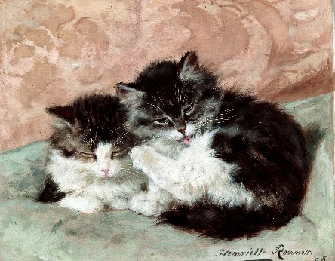  Happy Days, Henriette Ronner (1821–1909).  Atkinson Art Gallery Collection.
Belle of the Village, Alice Havers (1850–1890).  Atkinson Art Gallery Collection. | ‘I Promise To Love You’ Collection, 2013, Tracey Emin  Atkinson Art Gallery Collection.  © 2026 DACS

 | theatkinson.co.uk  01704 533 333 | The Atkinson  Lord Street  Southport  PR8 1DB

Inspirations Entry Form
Competition runs 13 June 2026 – 18 October 2026

The completed entry form, together with your competition entry, should be submitted and received by end of day Sunday 18 October 2026.

Email entries to: jemma.tynan@sefton.gov.uk
Postal entries to: Jemma Tynan, The Atkinson, Lord Street, Southport, PR8 1DB.

Personal Details | Your details will only be used for this competition and not for any other reason
Name
Age
Home Address

Telephone Number
Email Address
Details of entry
Title
Artwork(s) used as Inspiration
Entry Style
(e.g. poem, story etc)
Entry
(Can be sent as an attachment to your email. Please title the file:
Your Name, Title of inspiration artwork/s used)

